# LUTSF Award Report:

Cunningham Technique Teacher Training

Awardee: Yanaëlle Ritter

Dates of travel: 17th July – 5th August 2025

Location visited: New York City

## Project and achievements

This summer, I took part in the Cunningham Technique Teacher Training programme. The 2-week course offered by the Merce Cunningham Trust was held in New York City and included:

* open Cunningham Technique classes
* workshops on the back exercises, leg work, adagio, travelling phrases, jumps and creation of phrases inspired by repertory
* talks on effective ways to communicate with musicians and adapt the technique to different students’ levels
* and lectures on the technique’s fundamental principles and the history of Cunningham’s choreographic work.

Having initially applied in 2024, I got a place in the 2025 cohort and was one of 12 participants coming from the USA, Taiwan, Israel, France and the UK. Each of us led an hour-long warm up class and received feedback on our delivery. The course leader Jennifer Goggans helped us understand the order, pace and structure of the exercises, as well as key points for accurate execution. Adding to her expert knowledge of the technique, accompanist Jack Goode provided advice on ways of setting tempo, organising phrase lengths, counting him in, using subdivisions and cueing accompanists well while teaching. These opportunities to teach, observe, take part, discuss and reflect on so many classes and approaches to the technique were hugely insightful for me.

Since the Teacher Training ended, I completed 2 of the 15 lesson observations due by the end of May 2026 as final steps of the process. I miss taking classes in person, but I still use Cunningham Technique class videos to keep my practice alive. I’m going to teach a week of professional classes at The Place mid-November and another week at TripSpace mid-December. One of these 90-minute classes will be filmed and sent to the Trust as my final assessment to become an authorised Cunningham Technique teacher.

## Personal and professional impacts of my LUTSF-supported trip

This was my first trip to New York, so I took every opportunity to walk down the city’s scenic parks and giant grid of streets. Familiar names like Central Park and Broadway read many times before, suddenly became real around me. I immersed myself in the sounds, sights, smells, tastes and electrifying feel of the city. I felt intensely present to these new surroundings and very privileged to be there. Fascinated by the abundance of performances to see, I appreciated the ushers’ friendliness and the careful curation of dance events across informal, outdoor and traditional theatre settings. During my stay, I watched 1 opera, 1 open-air concert and 6 dance performances, including a sharing of ‘Pond Way’ restaged by the Merce Cunningham Trust.

My embodied understanding of the Cunningham Technique grew throughout the course. I didn’t hesitate to ask questions or share examples from my teaching practice. Structured and informal exchanges with facilitators and peers were rich and refreshing. I gained clarity on technical details I hadn’t picked up from pre-recorded classes, such as foot placement in the ‘in/out’ exercise and use of the arms with the spine in arches. The training also introduced me to complex exercises that were new to me, like the ‘around the leg’ series. Guided and inspired by expert teachers and former members of Merce Cunningham Dance Company, I pushed myself technically and felt incredibly lucky to experience over 20 individuals’ perspectives on the technique.

Lisa Boudreau, Janet Charleston, Jennifer Goggans, Mandy Kirschner-Salva, Jeannie Steele, Carol Teitelbaum, Andrea Weber and Anson Zwingelberg brought a wealth of embodied know-how to the sessions they led as part of the course. My peers Mariah Anton, Jacqueline Calle, Eve Jacobs, Xenia Mansour, Chalvar Monteiro, Adrien Mornet, Cho Ying Tsai and Jatie Tucker, whose warm ups I took part in, shared carefully constructed exercises, clear imagery and helpful themes through which to approach Cunningham classes: they drew my focus on risk-taking, community building, confidence, active use of the eyes and gaze, and more. Observing Moran Dekel, Reid Bartelme and Christopher-Rasheem McMillan’s warm ups sparked even more notes, thoughts and ideas. Before and after the Teacher Training, Kimberly Bartosik and Lindsey Jones challenged and inspired me with complex travelling patterns, thoroughly well-planned exercises and varied music choices in their open classes.

At weekends and before I left New York, I took a floorwork class with Marija Obradovic, a 3-hour workshop with independent dance artist Carmen Caceres, and 2 Limon classes with Nicholas Ruscica and Brandon Woods. Although my focus was on Cunningham Technique, I wanted to diversify my experience of the New York dance scene and felt delighted to return to the floor, breath-led actions and weighted swings through these practices. The outdoor Limon classes taught in Bryant Park were particularly joyful and inspired me to offer more open-air classes and workshops to my community in England.

## Highlights

The main highlight of my trip was the quality and profusion of dance classes I could take day after day. Being in a world-famous dance hub, enjoying the fast pace, challenges and excitement of Cunningham Technique classes, felt like a throwback to full-time dance training. New York gave me the thrill of transformation, of reaching the next level of dance technique. It felt like I was 18 and starting vocational training again, with added experience in dance teaching, and surrounded by highly skilled colleagues. The sweat was real, but beyond our physical work, the Teacher Training unlocked something in my mind. It helped me gently let go of what I thought I couldn’t do or wouldn’t ask students to do. There was a fearlessly positive ‘can do’ attitude in our classes. No tempo was too fast or too slow – we just gave anything a go. It felt uplifting and empowering. At times, I found myself balancing for longer, picking up exercises quicker or overall performing better than I thought I could. Maybe the only way to do it was indeed to do it.

Another highlight of my trip was to perform in America for the very first time! Having successfully applied for a performance slot at Dance Action’s Garden Series, I rehearsed and shared a solo with an intimate audience in Manhattan’s Upper West Side. The stage was a dance floor laid on the host’s terrace – another example of ‘can do’ mindset. I was thrilled to meet local dance makers there and immediately got along with artists like Marija Obradovic. Talking to them and hearing about New York’s independent dance scene helped me land and feel more like a local, and less like a tourist in the city.

A powerful piece I saw in New York was an excerpt of Witness Part III - Tomorrow by Ruddur Dance. Presented at New Victory Theater, it opened a programme of 3 pieces curated for young people and families. Two facilitators came on stage to introduce each work, offer prompts for reflection and lead a Q&A with the choreographers. After each piece, they taught the audience 8 counts of movement material which we performed from our seats, to echo and embody key gestures and moments of the works. At the end of the evening, we performed all 3 sequences one after the other, wrapping up the show with the delight of being active participants in it. This direct involvement of audiences felt hugely successful – a model of best practice for artists based in England and delivering the Arts Council’s agenda of participation and creative opportunities for all.

## Sharing information about my project with others

During my stay in New York, I shared a few photos, videos and reflections with my community via Instagram and Facebook. My posts and ‘stories’ kick-started many messages and exchanges with friends who had been to New York, were about to go, or hoped to visit the city in the future. A dance teacher friend told me that he was considering applying for the Cunningham Technique Teaching Training. I encouraged him to do so as it felt like a great fit for his skills and interests as a teacher.

Beyond these informal exchanges, I’m planning to publish this report on my blog, and to keep signposting the LUTSF and Cunningham Trust to the dance artists in my networks.

This autumn, the first ripples of my Teacher Training are reaching participants in the groups I teach. Jack Goode’s music features in the playlist for my adult contemporary dance classes in Eastbourne, and we are cleaning foot placement and other technical points ahead of their October show. I brought a book on Cunningham’s work back from New York and bought a digital resource pack developed by the Cunningham Trust. This resource will help me explore Cunningham’s choreographic methods with GSCE and BTEC dance students at a school in Bexhill.

## Suggestions for future awardees

I believe that, just like a good dance class, a smooth and fulfilling trip requires thoughtful planning. Before you travel, take the time to do your research and find out where and when you could take dance classes, watch performances, visit exhibitions or attend events alongside your main activity. Having an overview of venue and festival names will come in handy as you talk to local dance artists and enthusiasts. Follow their recommendations as well as your own interests and curiosity! You never know: the person you meet at one of your first open classes in a new city could be the one telling you about a brilliant, but niche dance festival you would otherwise have missed. Yes, that’s exactly what happened to me!

As you prepare for your trip, I also suggest mapping your journeys using Google Maps, City Mapper and/or local transport provider websites. If you can, book accommodation in a place that is well connected to public transport and not too far from the studio or venue where you will spend most of your time. For me, having a short, direct commute to New York City Center meant that I could sleep well, enjoy everything Manhattan had to offer, and travel to other boroughs easily. Subletting a friend of a friend’s flat was much more comfortable and affordable than staying at a Youth Hostel: I had access to a washing machine, cooked my own meals, and enjoyed quiet times between busy training days. I also ended up spending less than expected on food, even though I had been warned that eating in New York would be expensive.

Finally, what helped me make the most of my Teacher Training was to be physically prepared for it. I intentionally planned and taught Cunningham-based exercises to adult and teenage groups throughout the spring and summer terms. In the months leading to my departure, I also took and retook the pre-recorded Cunningham Technique classes for small spaces available from: https://app.ubindi.com/Merce.Cunningham.Trust

Once purchased, these videos can be replayed, which means that you can retake each class as many times as you like. Good luck!

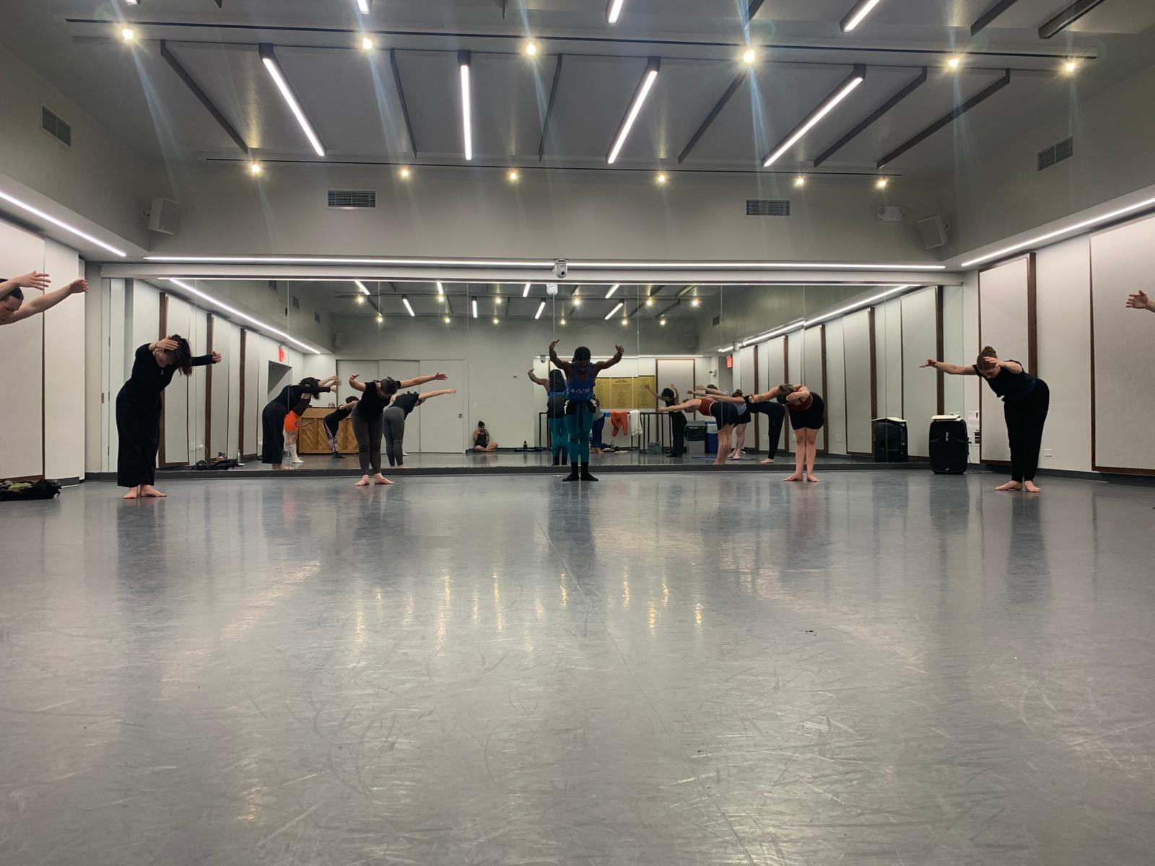

Warm up class led by Chalvar Monteiro at New York City Center Studios as part of the Cunningham Technique Teacher Training (31st July 2025). Photo by Mariah Anton-Arters.

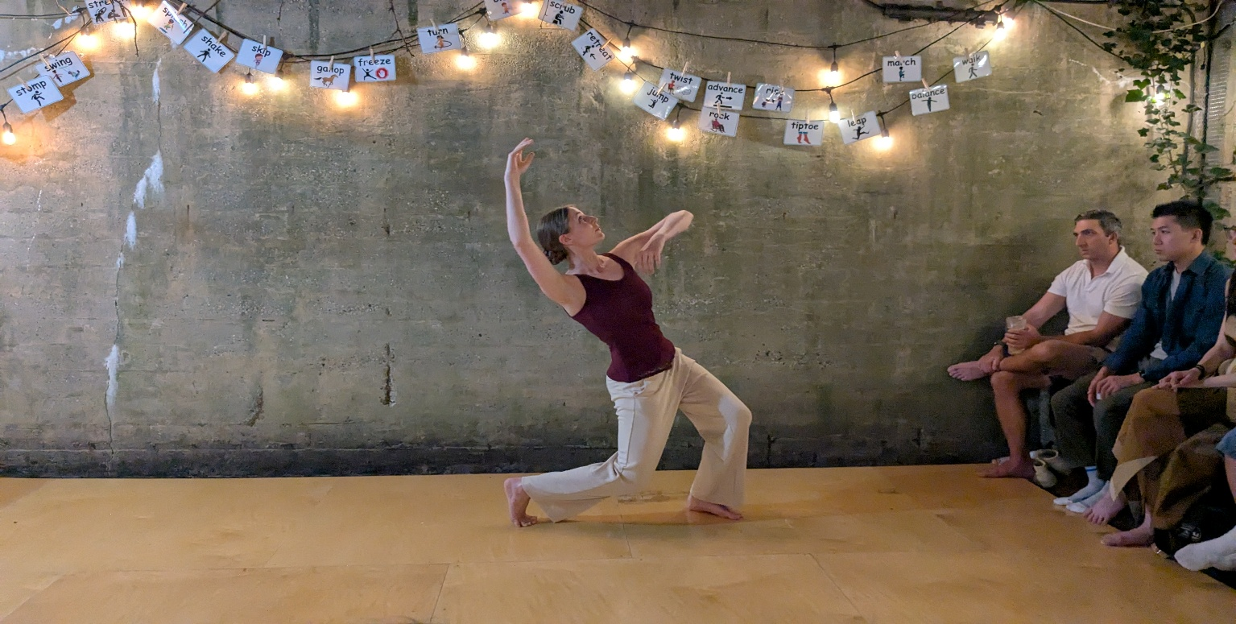

Yanaëlle Ritter performing an excerpt of ‘Echoes of a Journey’ at Dance Action’s Garden Series event hosted by Carmen Caceres in Manhattan (18th July 2025). Photo by Dmytro Lituiev.